**SUPPLEMENTAL INFORMATION**

**S.1 Hydraulic Conductivity of Hepatic Lobule**

Hydraulic conductivity (K) can be expressed in units of m/s. In Equation S.2, the hydraulic conductivity of the lobule is expressed as a function of fluid properties (*ρ,* fluid density in kg/m3, and *μ,* dynamic viscosity in Pa ∙ s), average radius of the sinusoids (*r2*), the gravitational constant (*g* in m/s2) and the void ratio of the lobule (*e*):

 (Eq. S.1)

where void ratio, *e*, is defined as:

 (Eq. S.2)

*VT* is the total lobule volume, *Vv* is the void volume of the lobule, and *Vs* is the solid volume of the lobule. For a fluid-saturated porous material, void spaces are considered to be filled with fluid.

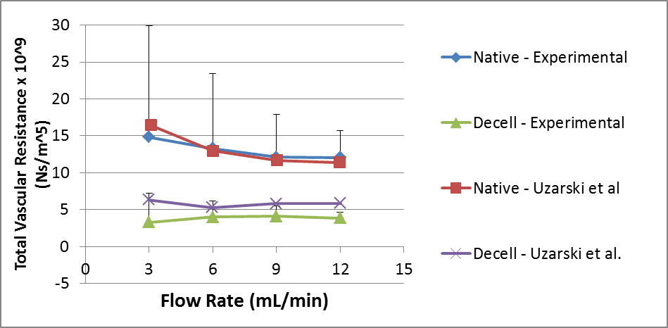

**Figure S.1** Total right lobe resistance for native (blue) and decellularized (green) ferret livers was determined from pressure drop experiments. These experimental results agreed well with total right lobe resistance for native (red) and decellualrized (purple) rat livers, calculated from the results of Uzarski et al. (2015).

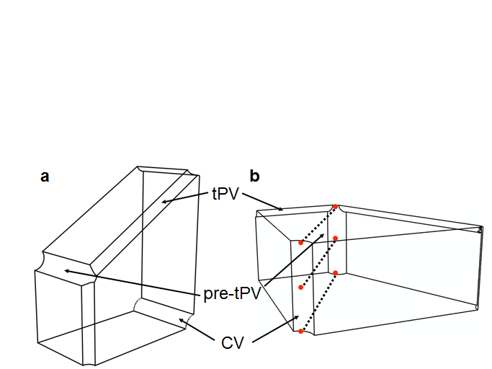

**Figure S.2** Three paths from tPV to CV were selected and results along these paths were averaged to generate the average model results reported for each condition. (a) quarter lobule geometry; (b) three paths shown as dashed lines.

**S.2 Native Lobule Results**

**3 mL/min**

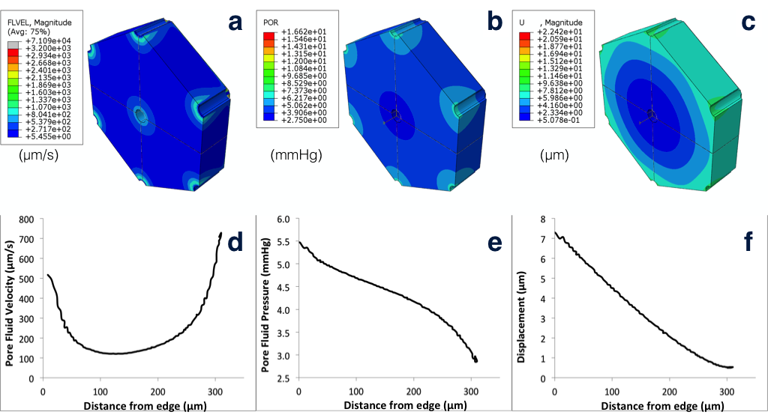

**Figure S.3.** Pore fluid velocity (a, d), pore fluid pressure (b, e), and solid matrix displacement (c,f) results for native lobule model when the right lobe is perfused at 3 mL/min.

**3 mL/min**

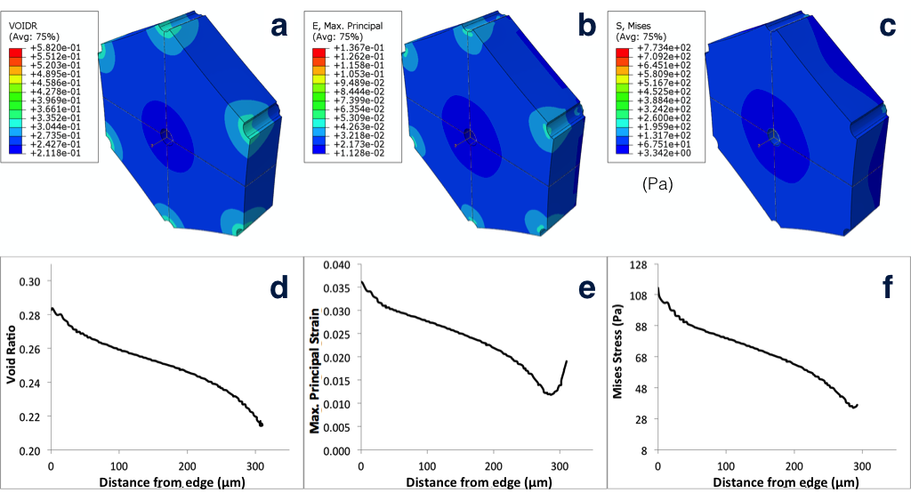

**Figure S.4.** Void ratio (a,d), maximum principal strain (b,e), and von Mises stress (c,f) results for native lobule model when the right lobe is perfused at 3 mL/min.

**6 mL/min**

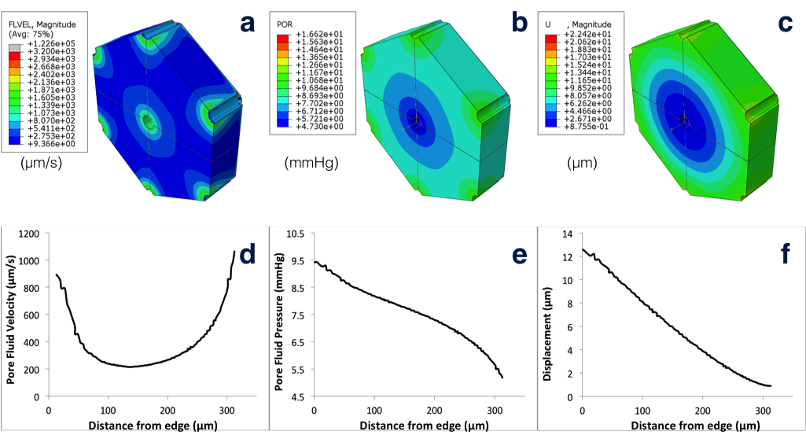

**Figure S.5.** Pore fluid velocity (a, d), pore fluid pressure (b, e), and solid matrix displacement (c,f) results for native lobule model when the right lobe is perfused at 6 mL/min.

**6 mL/min**

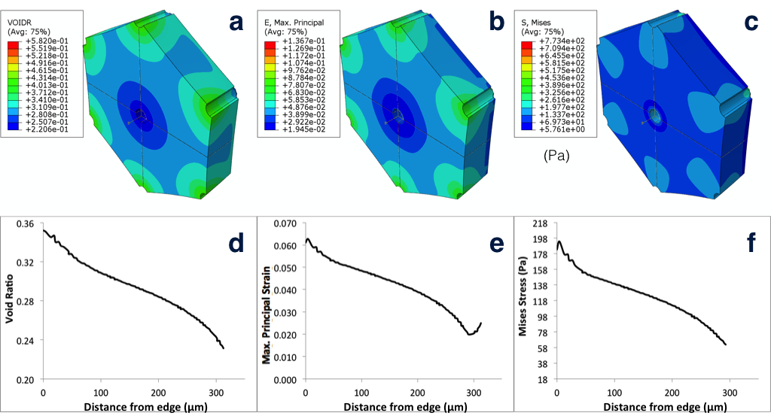

**Figure S.6.** Void ratio (a,d), maximum principal strain (b,e), and von Mises stress (c,f) results for native lobule model when the right lobe is perfused at 6 mL/min.

**9 mL/min**

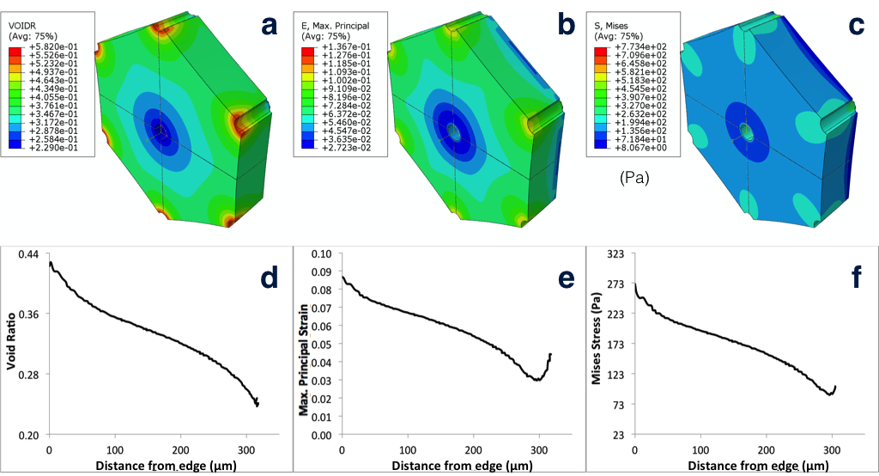

**Figure S.7.** Void ratio (a,d), maximum principal strain (b,e), and von Mises stress (c,f) results for native lobule model when the right lobe is perfused at 9 mL/min. Pore fluid velocity, pore fluid pressure, and solid matrix displacement results for 9 mL/min are given in Fig. 8 in the text.

**12 mL/min**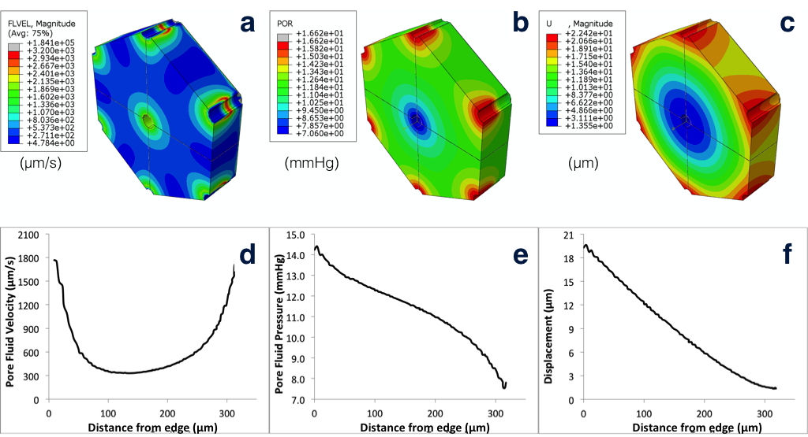

**Figure S.8.** Pore fluid velocity (a, d), pore fluid pressure (b, e), and solid matrix displacement (c,f) results for native lobule model when the right lobe is perfused at 12 mL/min.

**12 mL/min**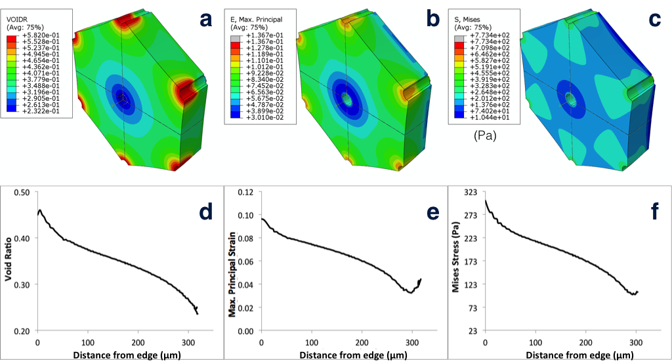

**Figure S.9.** Void ratio (a,d), maximum principal strain (b,e), and von Mises stress (c,f) results for native lobule model when the right lobe is perfused at 12 mL/min.

**Table S.1** Summary of native lobule FE model results for four experimental flow rates.

|  |  |  |  |  |  |
| --- | --- | --- | --- | --- | --- |
|  | Flow Rate (mL/min) | 3 | 6 | 9 | 12 |
| **S**  **(Pa)** | ave | 68.75 | 120.83 | 165.57 | 181.75 |
| max | 112.26 | 193.82 | 270.95 | 302.53 |
| min | 35.12 | 61.822 | 87.89 | 100.34 |
| **POR (mmHg)** | ave | 4.136 | 7.399 | 10.20 | 10.81 |
| max | 5.467 | 9.422 | 13.21 | 14.40 |
| min | 2.857 | 5.184 | 6.944 | 7.218 |
| **FLVEL (μm/s)** | ave | 253.7 | 408.4 | 609.1 | 753.4 |
| max | 705.3 | 1062 | 1658 | 1992 |
| min | 120.7 | 213.9 | 292.1 | 330.1 |
| **U**  **(μm)** | ave | 2.843 | 5.290 | 7.163 | 7.546 |
| max | 7.284 | 12.59 | 17.66 | 19.60 |
| min | 0.509 | 0.893 | 1.233 | 1.368 |
| **E** | ave | 0.023 | 0.040 | 0.055 | 0.060 |
| max | 0.036 | 0.063 | 0.087 | 0.096 |
| min | 0.012 | 0.020 | 0.030 | 0.033 |
| **VOIDR** | ave | 0.240 | 0.288 | 0.323 | 0.334 |
| max | 0.284 | 0.352 | 0.428 | 0.460 |
| min | 0.214 | 0.231 | 0.237 | 0.236 |

**S.3 Decellularized Lobule Results**

**3 mL/min**

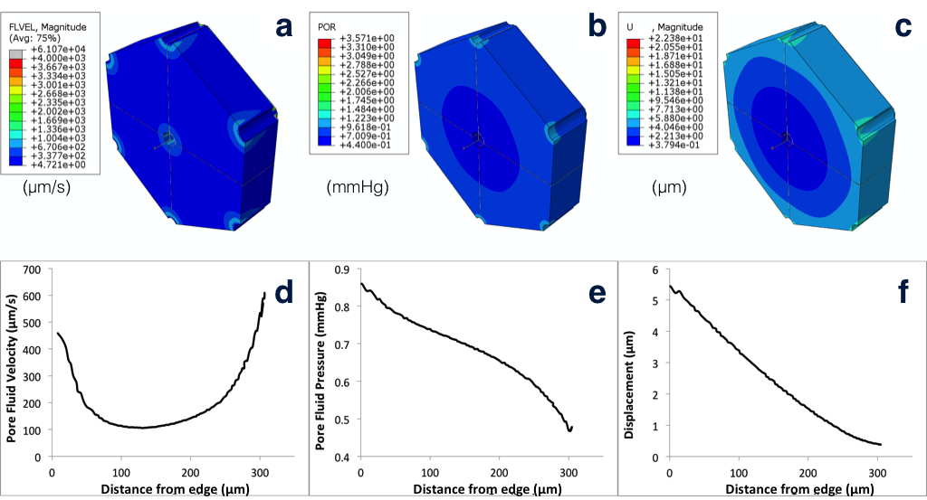

**Figure S.10.** Pore fluid velocity (a, d), pore fluid pressure (b, e), and solid matrix displacement (c,f) results for decellularized lobule model when the right lobe is perfused at 3 mL/min.

**3 mL/min**

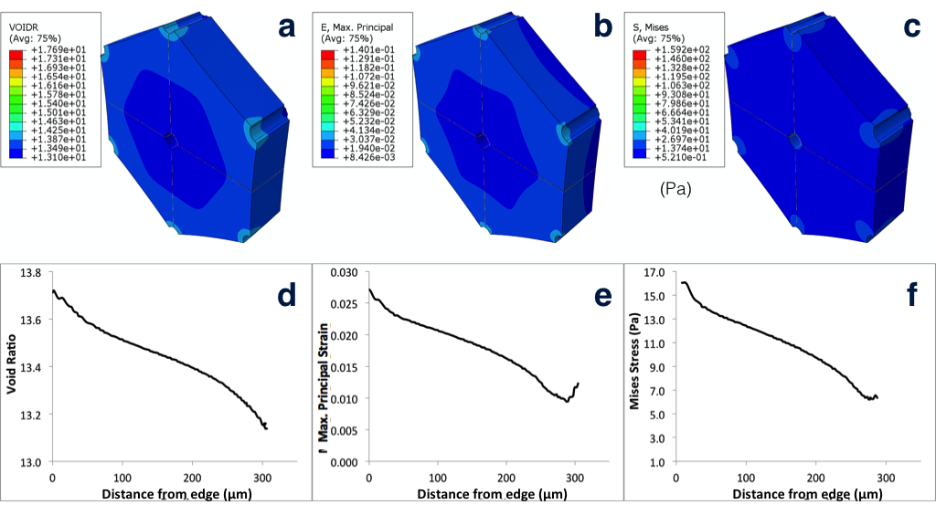

**Figure S.11.** Void ratio (a,d), maximum principal strain (b,e), and von Mises stress (c,f) results for decellularized lobule model when the right lobe is perfused at 3 mL/min.

**6 mL/min**

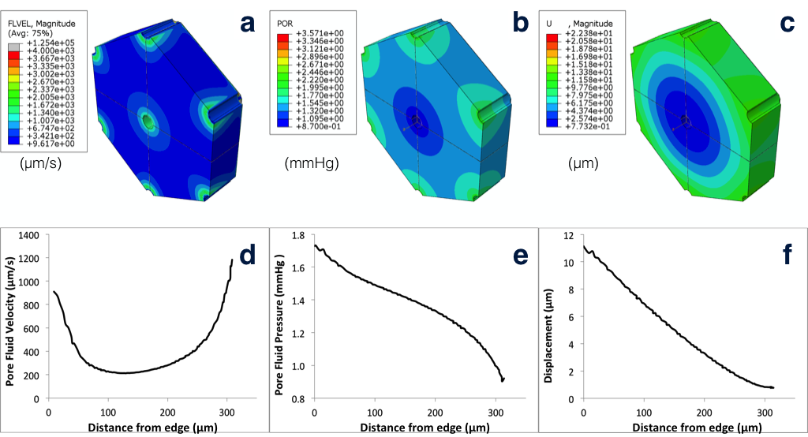

**Figure S.12.** Pore fluid velocity (a, d), pore fluid pressure (b, e), and solid matrix displacement (c,f) results for decellularized lobule model when the right lobe is perfused at 6 mL/min.

**6 mL/min**

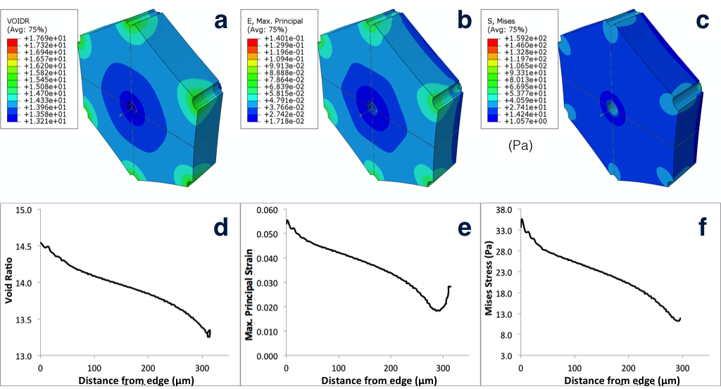

**Figure S.13.** Void ratio (a,d), maximum principal strain (b,e), and von Mises stress (c,f) results for decellularized lobule model when the right lobe is perfused at 6 mL/min.

**9 mL/min**

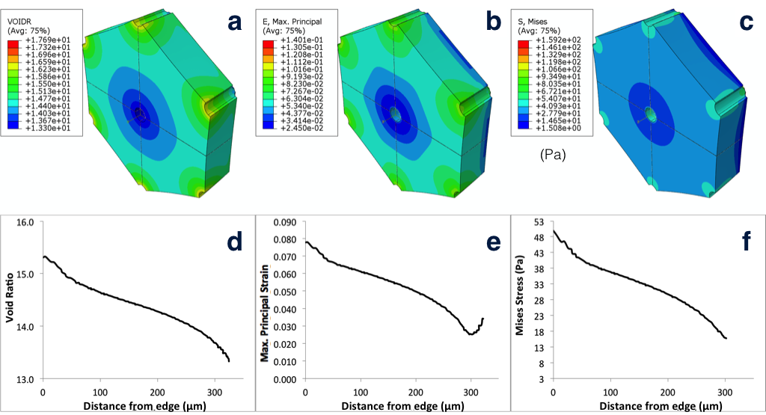

**Figure S.14.** Void ratio (a,d), maximum principal strain (b,e), and von Mises stress (c,f) results for decellularized lobule model when the right lobe is perfused at 9 mL/min. Pore fluid velocity, pore fluid pressure, and solid matrix displacement results for 9 mL/min are given in Fig. 9 in the text.

**12 mL/min**

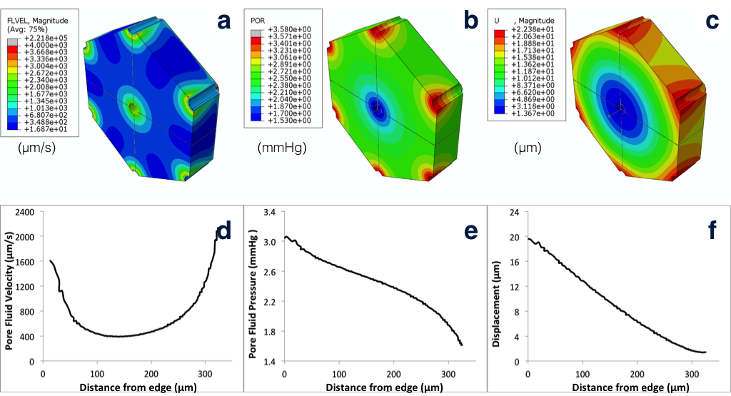

**Figure S.15.** Pore fluid velocity (a, d), pore fluid pressure (b, e), and solid matrix displacement (c, f) results for decellularized lobule model when the right lobe is perfused at 12 mL/min.

**12 mL/min**

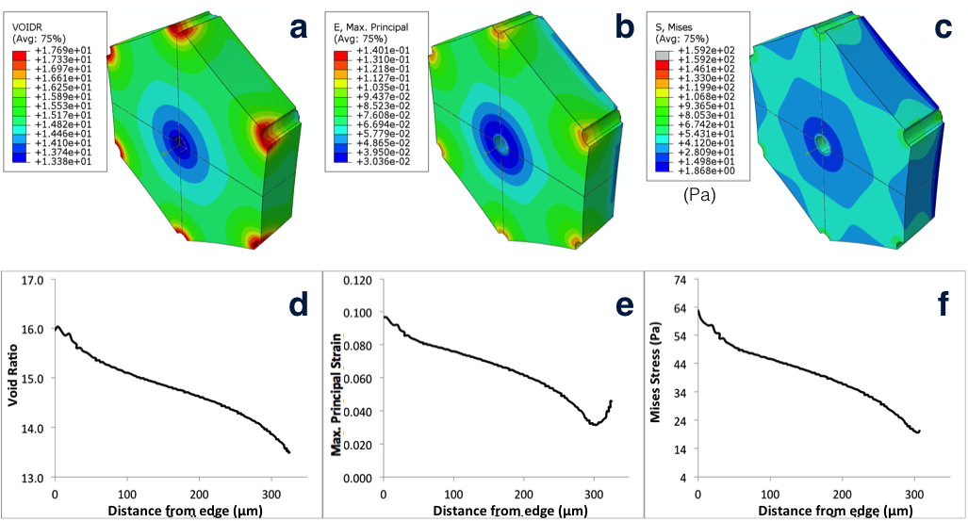

**Figure S.16.** Void ratio (a,d), maximum principal strain (b,e), and von Mises stress (c,f) results for decellularized lobule model when the right lobe is perfused at 12 mL/min.

**Table S.2** Summary of decellularized lobule FE model results for four experimental flow rates.

|  |  |  |  |  |  |
| --- | --- | --- | --- | --- | --- |
|  | Flow Rate (mL/min) | 3 | 6 | 9 | 12 |
| **S (Pa)** | ave | 10.61 | 21.58 | 31.25 | 38.37 |
| max | 16.60 | 35.57 | 49.85 | 62.73 |
| min | 6.24 | 11.247 | 15.76 | 19.68 |
| **POR (mmHg)** | ave | 0.6653 | 1.328 | 1.894 | 2.365 |
| max | 0.8592 | 1.731 | 2.463 | 3.058 |
| min | 0.4683 | 0.9041 | 1.266 | 1.615 |
| **FLVEL (μm/s)** | ave | 211.4 | 455.4 | 618.0 | 767.1 |
| max | 570.2 | 1242.6 | 1677 | 2127 |
| min | 105.4 | 212.5 | 309.7 | 389.6 |
| **U (μm)** | ave | 2.180 | 4.338 | 6.343 | 7.988 |
| max | 5.446 | 11.122 | 16.01 | 19.58 |
| min | 0.384 | 0.774 | 1.128 | 1.402 |
| **E** | ave | 0.017 | 0.034 | 0.049 | 0.061 |
| max | 0.027 | 0.055 | 0.078 | 0.097 |
| min | 0.009 | 0.018 | 0.025 | 0.031 |
| **VOIDR** | ave | 13.409 | 13.621 | 14.272 | 14.641 |
| max | 13.72 | 14.54 | 15.32 | 16.03 |
| min | 13.14 | 13.26 | 13.33 | 13.49 |

**S.4 Physiological Model Results**

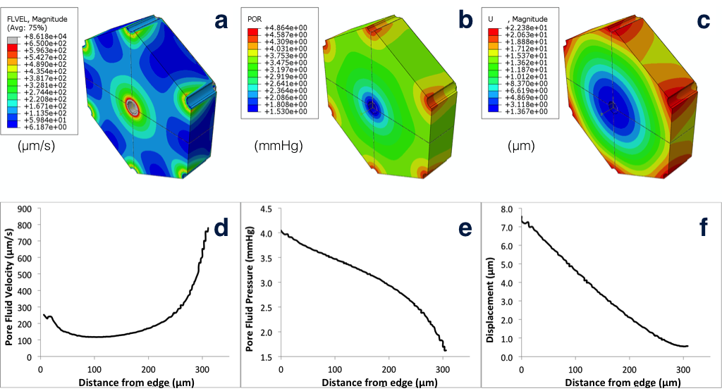

**Figure S.17.** Pore fluid velocity (a, d), pore fluid pressure (b, e), and solid matrix displacement (c,f) results for native lobule model when physiological pressure gradients (Table S.3) are used as boundary conditions on the pre-terminal PV, terminal PV, and CV surfaces.

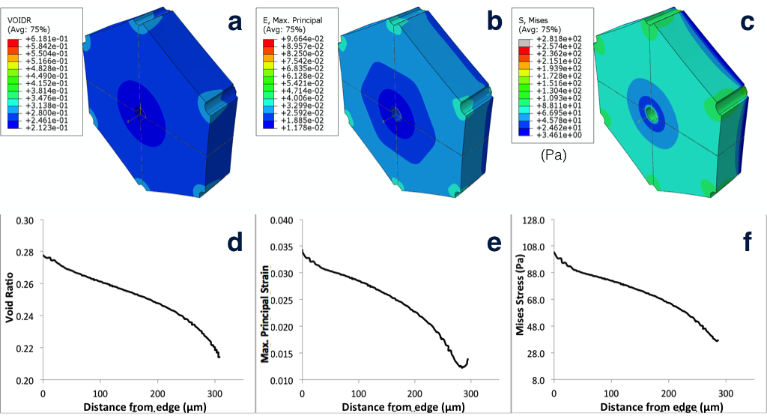

**Figure S.18.** Void ratio (a,d), maximum principal strain (b,e), and von Mises stress (c,f) results for native lobule model when physiological pressure gradients (Table S.3) are used as boundary conditions on the pre-terminal PV, terminal PV, and CV surfaces.

**Table S.3** Physiological pressure gradients in pre-tPV, tPV, and CV were estimated from (Debbaut et al., 2012) and (Oda et al., 2003) and used as lobule boundary conditions for model validation.

|  |  |  |
| --- | --- | --- |
| **Physio BC (mmHg)** | **pre-tPV** | 2.93 |
| **terminalPV** | 2.23 |
| **CV** | 0 |
| **Base line P** | 1.47 |

Note: In the physiological model, CV surface pressure was set to zero to serve as a fluid sink. Non-zero baseline CV pressure (1.47 mmHg) was subtracted from reported pressures in pre-tPV (4.4 mmHg), and tPV (3.7 mmHg), yielding the pressure gradients shown in Table S.3.

**Table S.4** Summary of native lobule FE model results when physiological pressure gradients are used as boundary conditions on pre-tPV, tPV, and CV surfaces.

|  |  |  |
| --- | --- | --- |
| **S**  **(Pa)** | ave | 70.45 |
| max | 105.59 |
| min | 36.746 |
| **POR (mmHg)** | ave | 2.996 |
| max | 4.042 |
| min | 1.624 |
| **FLVEL (μm/s)** | ave | 253.5 |
| max | 778.3 |
| min | 117.4 |
| **U**  **(μm)** | ave | 3.069 |
| max | 7.542 |
| min | 0.5468 |
| **E** | ave | 0.0238 |
| max | 0.0343 |
| min | 0.0122 |
| **VOIDR** | ave | 0.2490 |
| max | 0.2777 |
| min | 0.2142 |

**Table S.5** Vascular geometries used in electrical analog models

|  |  |  |  |  |  |  |  |
| --- | --- | --- | --- | --- | --- | --- | --- |
| SRL | | | | | | | |
| PV | | | | HV | | | |
| n | r (m) | l (m) | Rs (Ns/m5) | n | r (m) | l (m) | Rs (Ns/m5) |
| 1 | 2.20.E-03 | 2.40.E-02 | 2.08E+06 | 197348 | 5.31.E-06 | 5.06.E-05 | 6.55E+08 |
| 1 | 7.09.E-04 | 7.53.E-03 | 6.05E+07 | 59440 | 8.67.E-06 | 8.42.E-05 | 5.10E+08 |
| 2 | 4.74.E-04 | 5.52.E-03 | 1.11E+08 | 17903 | 1.41.E-05 | 1.40.E-04 | 3.97E+08 |
| 5 | 3.60.E-04 | 4.05.E-03 | 9.80E+07 | 5392 | 2.31.E-05 | 2.34.E-04 | 3.09E+08 |
| 12 | 2.60.E-04 | 2.97.E-03 | 1.10E+08 | 1624 | 3.77.E-05 | 3.89.E-04 | 2.41E+08 |
| 28 | 8.40.E-05 | 2.18.E-03 | 3.18E+09 | 489 | 5.60.E-05 | 6.48.E-04 | 2.74E+08 |
| 66 | 8.40.E-05 | 1.60.E-03 | 9.88E+08 | 147 | 1.21.E-04 | 1.08.E-03 | 6.95E+07 |
| 156 | 8.40.E-05 | 1.17.E-03 | 3.07E+08 | 44 | 1.79.E-04 | 1.80.E-03 | 8.08E+07 |
| 368 | 6.40.E-05 | 8.60.E-04 | 2.83E+08 | 13 | 3.76.E-04 | 2.99.E-03 | 2.34E+07 |
| 869 | 3.90.E-05 | 6.31.E-04 | 6.37E+08 | 4 | 3.28.E-04 | 4.98.E-03 | 2.19E+08 |
| 2054 | 3.33.E-05 | 4.63.E-04 | 3.74E+08 | 1 | 8.05.E-04 | 8.29.E-03 | 4.01E+07 |
| 4853 | 2.37.E-05 | 3.39.E-04 | 4.52E+08 | 1 | 5.30.E-03 | 4.30.E-02 | 1.11E+05 |
| 11469 | 1.68.E-05 | 2.49.E-04 | 5.47E+08 |  |  |  |  |

|  |  |  |  |  |  |  |  |
| --- | --- | --- | --- | --- | --- | --- | --- |
| IRL | | | | | | | |
| PV | | | | HV | | | |
| n | r (m) | l (m) | Rs (Ns/m5) | n | r (m) | l (m) | Rs (Ns/m5) |
| 1 | 2.20.E-03 | 2.40.E-02 | 2.08E+06 | 102669 | 5.93.E-06 | 5.49.E-05 | 8.78E+08 |
| 1 | 4.56.E-04 | 7.53.E-03 | 3.54E+08 | 30923 | 9.68.E-06 | 9.15.E-05 | 6.84E+08 |
| 2 | 3.71.E-04 | 5.52.E-03 | 2.96E+08 | 9314 | 1.58.E-05 | 1.52.E-04 | 5.33E+08 |
| 5 | 2.47.E-04 | 4.05.E-03 | 4.42E+08 | 2805 | 2.58.E-05 | 2.54.E-04 | 4.15E+08 |
| 13 | 1.47.E-04 | 2.97.E-03 | 9.94E+08 | 845 | 5.50.E-05 | 4.22.E-04 | 1.11E+08 |
| 30 | 1.01.E-04 | 2.18.E-03 | 1.42E+09 | 254 | 6.80.E-05 | 7.03.E-04 | 2.63E+08 |
| 70 | 8.00.E-05 | 1.60.E-03 | 1.13E+09 | 77 | 9.00.E-05 | 1.17.E-03 | 4.71E+08 |
| 165 | 6.20.E-05 | 1.17.E-03 | 9.77E+08 | 23 | 1.45.E-04 | 1.95.E-03 | 3.90E+08 |
| 391 | 4.22.E-05 | 8.60.E-04 | 1.41E+09 | 7 | 2.89.E-04 | 3.25.E-03 | 1.35E+08 |
| 923 | 3.00.E-05 | 6.31.E-04 | 1.71E+09 | 2 | 5.14.E-04 | 5.41.E-03 | 7.87E+07 |
| 2182 | 2.14.E-05 | 4.63.E-04 | 2.06E+09 | 1 | 7.96.E-04 | 9.01.E-03 | 4.55E+07 |
| 5157 | 1.52.E-05 | 3.39.E-04 | 2.49E+09 |  |  |  |  |

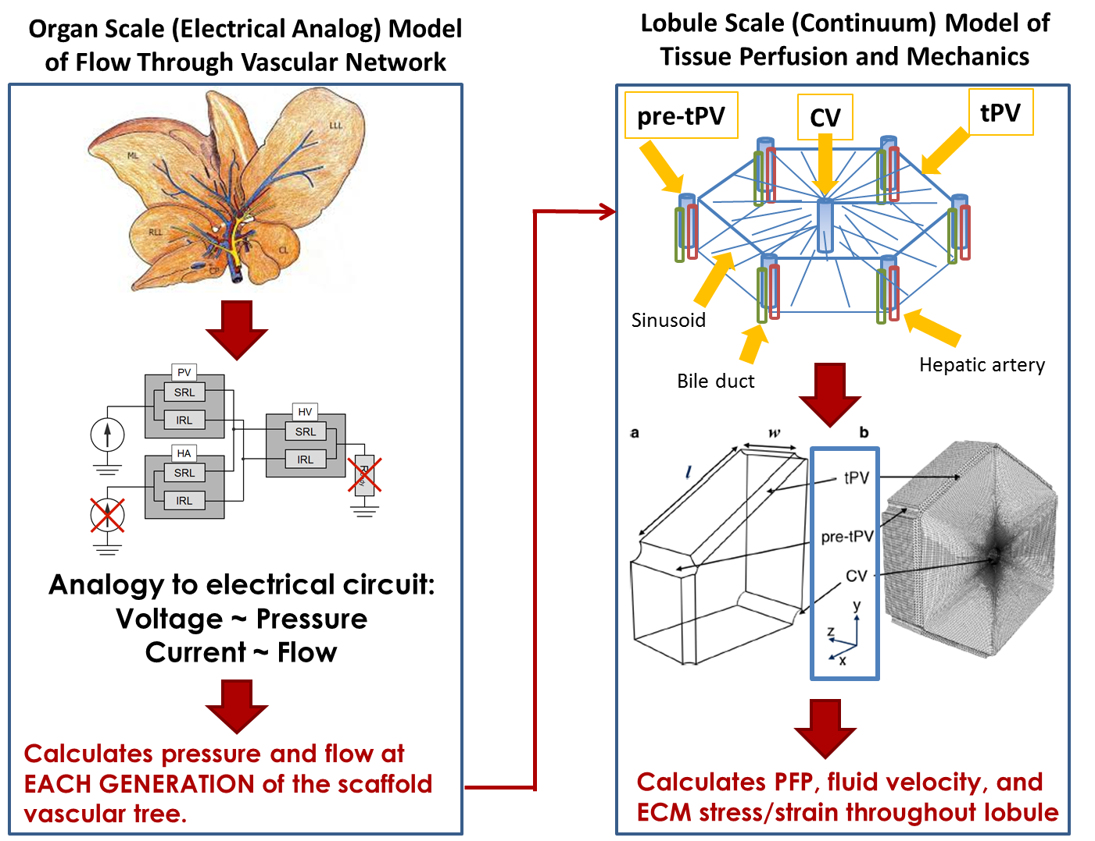

**Figure S.19.** Overview of modeling approach. Flow rate through the PV was used as input to the electrical analog model. Pressures at specific blood vessel generations (pre-tPV, tPV, CV), taken as output from the electrical model for a specific flow rate, were then used as boundary conditions in those vessels to drive flow through the lobule model. The lobule model output includes pore fluid velocity (akin to interstitial fluid velocity), pore fluid pressure (akin to interstitial fluid pressure), and extracellular matrix deformation and stress. (Rat liver sketch in top left is adapted from Aller et al. [S7] under Creative Commons license CC-BY.)

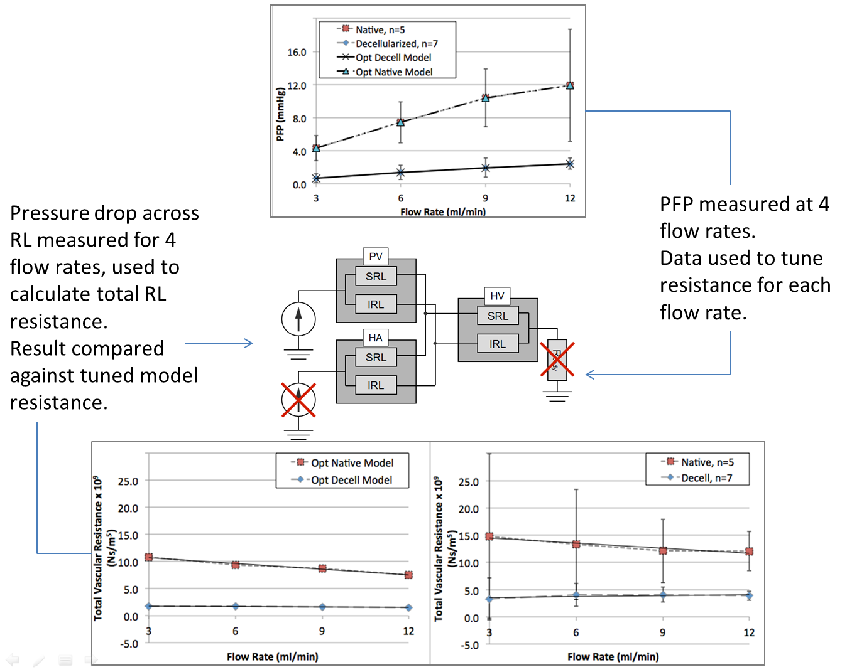

**Figure S.20. Overview of electrical analog model optimization and validation.** The resistance of the electrical analog model was optimized such that the model accurately predicted measured PFP for each flow rate, for native or decellularized liver. To validate the optimized resistance values for each condition, they were compared against total right lobe resistance measured at each flow rate in the pressure drop experiments. Results of the pressure drop experiments also agreed well with those of Uzarski et al. (2015), as shown in Fig. S.1.

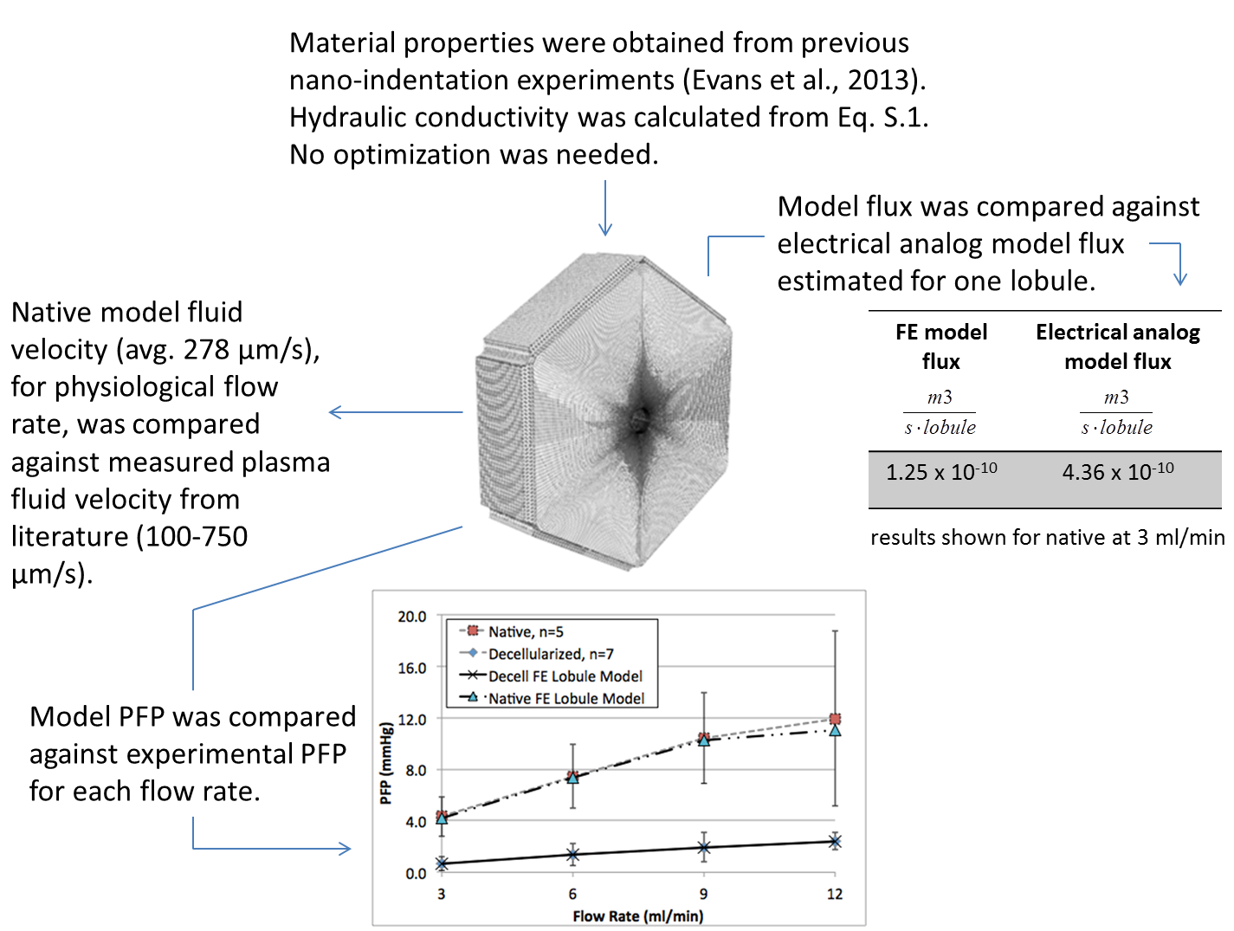

**Figure S.21. Overview of lobule finite element model optimization and validation.** Three validation strategies indicated good agreement between the FE model predictions and (1) independent measures of plasma fluid velocity, (2) experimental measures of parenchymal fluid pressure (PFP), and (3) flux per lobule estimated from the electrical analog model. In addition, model hydraulic conductivity for native liver (1.85 x 10-6 m/s), calculated using Eq. S.1, is in good agreement with the reported range (0.24x10-6 to 9.9x10-6 m/s) (Kerdok, 2006; Debbaut et al., 2012).

Flux was calculated for the FE model by summing up the reaction fluid volume flux (RVF) for all nodes on the surface of the central vein (CV) in the model. For the full lobule, this flux was found to be 1.25 x 10-10 m3/(s ∙ lobule) for the 3 mL/min flow rate applied to native liver. This flux was compared with that obtained from the electrical analog model at the same flow rate, to check consistency between models. To determine electrical analog model flux on a per lobule basis, the number of sinusoids per lobule was estimated, assuming lobule dimensions equal to those of the FE model. Our approach was as follows. Void ratio for the native model (0.2) was used to calculate the total sinusoid volume in one lobule. The volume of one sinusoid was calculated from the appropriate vessel dimension in Table S.5. From these two values, it was possible to estimate the number of sinusoids in one lobule as ~2600. The estimated electrical analog flux per lobule was then calculated, for the 3 mL/min flow rate, as:



This estimate is of the same order of magnitude as that calculated from the FE model (assuming consistent lobule dimensions), which is reasonable given the uncertainty of estimating electrical analog model flux on a per lobule basis.

**S.5 Poroviscoelasticity**

Mathematical details of PVE theory and its application to liver tissue have been reported elsewhere (Raghunathan et al., 2010; Moran et al., 2012b; Evans et al., 2013) and are summarized briefly here, adapted from Evans et al. (2013) and Athanasiou and Natoli [S1]. Poroviscoelasticity (PVE) theory extends biphasic theory to include inherent viscoelasticity of the solid component [S2]. A biphasic model consists of a linear elastic incompressible solid and an incompressible liquid, such that relative motion between these two phases generates rate-dependent behavior [S3]. If the liquid phase is inviscid, biphasic theory is equivalent to poroelasticity theory (Simon, 1992), which has been used widely in soil mechanics and more recently in simulations of soft biphasic biological tissues [S4,S5]. Equations S.3 through S.9 govern biphasic theory. Equations S.10 and S.11 extend biphasic theory to accommodate inherent viscoelasticity of the solid component. Equations S.12 and S.13 complete the constitutive description.

For an incompressible solid phase and incompressible fluid phase, the conservation of mass can be written as:

 (Eq. S.3)

where *s* and *f* indicate solid and fluid phase, respectively, **and **are the solid and fluid volume fractions, and *v* is velocity. If inertial forces are assumed much smaller than internal frictional forces, the conservation of linear momentum can be written as:

 (Eq. S.4)

 (Eq. S.5)

where  and are Cauchy stress tensors and and  are viscous drag forces that represent the interaction force between the fluid and solid phases. and are assumed proportional to their relative velocities and inversely proportional to hydraulic permeability, *k*:

 (Eq. S.6)

Stress in the fluid and solid phases can be written as:

 (Eq. S.7)

 (Eq. S.8)

where *p* is hydrostatic pressure and  is apparent solid stress due to solid matrix deformation [S2,S3,S6].

If the solid phase is modeled as a linear elastic material, then can be written as:

 (Eq. S.9)

where is the infinitesimal strain tensor and *λ* and *μ* are Lame constants.

To account for inherent viscoelasticity of the solid phase, the solid stress tensor can be replaced with:

 (Eq. S.10)

where *G* and *K* are elastic shear and bulk relaxation functions,  is deviatoric strain, and  is volumetric strain [S2,S6]. The relaxation functions can be defined using a Prony series expansion:

 (Eq. S.11)

where *R* is the time-dependent modulus,  is the long-term modulus, and *n*, *ri*, *τi* are Prony series parameters.

In the Abaqus implementation in this study, the material behavior was defined by specifying the hydraulic conductivity (*K*), the specific weight of the liquid (*γ*), the Prony series parameters, a long-term Young’s modulus (), and Poisson’s ratio (ν) so that:

 (Eq. S.12)

 (Eq. S.13)

**Supplemental Information References**

S1. Athanasiou KA, Natoli RM. Introduction to Continuum Biomechanics. Morgan and Claypool, 2009.

S2. Mak AF. The apparent viscoelastic behavior of articular cartilage – the contributions from the intrinsic matrix viscoelasticity and interstitial fluid flows. J Biomech Eng 1986;108(2):123-130.

S3. Mow VC, Kuei SC, Lai WM, Armstrong CG. Biphasic creep and stress relaxation of articular cartilage in compression: Theory and experiments. J Biomech Eng 1980;102(1):73-84.

S4. Cheng S, Bilston LE. Unconfined compression of white matter. J Biomech 2007;40(1):117-124.

S5. Wu JZ, Herzog W, Epstein M. Evaluation of the finite element software abaqus for biomechanical modelling of biphasic tissues. J Biomech 1997;31(2):165-169.

S6. Suh JK, Bai S. Finite element formulation of biphasic poroviscoelastic model for articular cartilage. J Biomech Eng 1998;120(2):195-201.

S7. Aller MA, Arias JL, Garcia-Dominguez J, Arias JI, Duran M, Arias J. Experimental obstructive cholestasis: the wound-like inflammatory liver response. Fibrogenesis and Tissue Repair 2008;1(6): doi: 10.1186/1755-1536-1-6.